The Bronx Center for Science and Mathematics

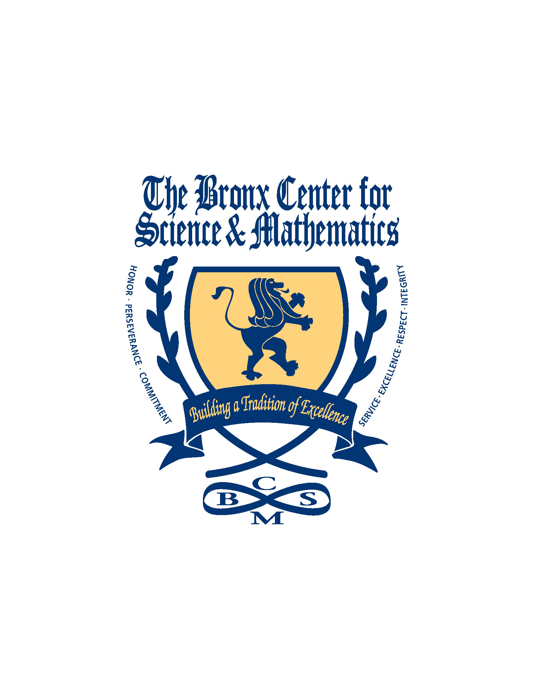
A Magnet School
1363 Fulton Avenue

Bronx, New York 10456

Tele # (718) 992-7089 – Fax # (718) 590-1052
Edward Tom, Founding Principal

Please complete the following information:

Student name: ___________________________________________

Parent/Guardian Name: ____________________________________

_________ Refund the senior trip deposit (refunds will be paid via check unless the original deposit was paid via PayPal. PayPal deposits will be refunded to the credit or debit card used)

Who should the check be made out to? ________________________________________

________ Apply Deposit to the Senior Prom

________ Apply deposit to Senior Dues

Signed,

______________________________________
Parent/Guardian Date

______________________________________
Student Date

